Solubility:
- [Molecule 1] (solute-solute) intermolecular forces are: …
- [Molecule 2] (solvent-solvent) intermolecular forces are: …
- The solute-solvent forces of attraction are: …
- These are (not) strong enough to overcome the solute-solute and solvent-solvent intermolecular forces so [Molecule 1] dissolves in [Molecule 2].

Functional groups:
Functional group: | General formula: | Suffix: | Intermolecular forces present:
Alcohol | 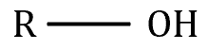 | –ol | - Hydrogen bonding  - Dipole-dipole forces  - Dispersion forces
Aldehyde | 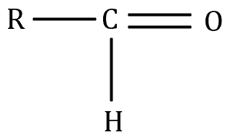 | –al | - Dipole-dipole forces  - Dispersion forces
Ketone | 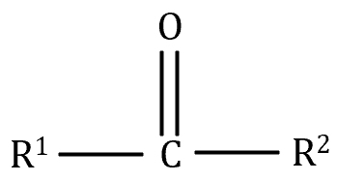 | –one | - Dipole-dipole forces  - Dispersion forces
Amine | 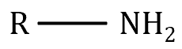 | –amine | - Hydrogen bonding  - Dipole-dipole forces  - Dispersion forces
Amide | 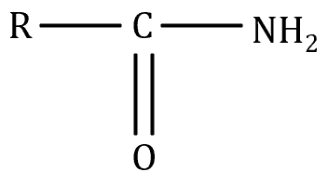 | –amide | - Hydrogen bonding  - Dipole-dipole forces  - Dispersion forces
Carboxylic acid | 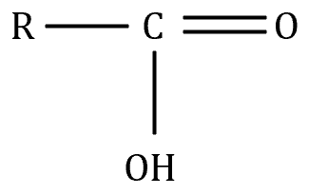 | –oic | - Hydrogen bonding  - Dipole-dipole forces  - Dispersion forces
Ester | 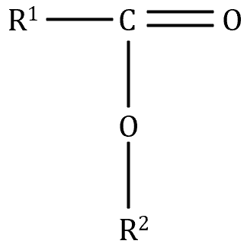 | –(alkyl group attached to single bonded oxygen)–… –oate | - Dipole-dipole forces  - Dispersion forces

Priority:
- Carboxylic acid
- Ester
- Amide
- Aldehyde
- Ketone
- Alcohol
- Amine
- Alkyl groups + halogens
Can’t Eat An Ant, Keto Life is My Life

